**Arduino Based Autonomous Fire Fighting Robot**

This advanced firefighting robotic system independently detects and extinguishes fire. In the age of technology, the world is slowly turning towards the automated system and self-travelling vehicles, fire fighters are constantly at a risk of losing their life. Fire spreads rapidly if it is not controlled. In case of a gas leakage there even may be an explosion. So, in order to overcome this issue, safe guard live of our hero, our system comes to the rescue. This firefighting robotic system is powered by Arduino Uno development board it consists of the HC-SR04 ultra-sonic sensor mounted on a servo motor for obstacles detection and free path navigation, it is also equipped with the fire flame sensor for detecting and approaching fire it also makes use of water tank and spray mechanism for extinguishing the fire. Water spraying nozzle is mounted on servo motor to cover maximum area. Water is pumped from the main water tank to the water nozzle with the help of 12V pump. This water pump needs driver circuit as it consumes a lot of current, much more than the controller provides.

**Components**

**Servo motors :**

**For the water gun mechanism what we needed was to have motors that can provide relatively precise motion in a specific range.**

**Ultrasonic sensors:**

**These are used for being able of avoiding obstacles. We have used 2 sensors, however you can increase the range of observable area by increasing the number of sensors. (Effective range of each ultrasonic sensor : 15 degrees)**

**Flame sensors :**

**Totally 4 flame sensors are used . 3 sensors under the chassis are connected to both analogue and digital pins of Arduino. The digital connections are used for detecting the fire for further actions while the analogue connections are used only to provide readings of the distance to fire for the user. The other sensor on the top is used digitally and it's function is to send the command for stopping the vehicle at a suitable distance from the fire, so in the moment that the sensor on the top which has an specific angle detect the fire, it will send the command for stopping the vehicle and starting the pump the water and running the water gun to put the fire off.**

**Arduino Uno:**

**Arduino Uno is a microcontroller board based on the ATmega328P (datasheet). It has 14 digital input/output pins (of which 6 can be used as PWM outputs), 6 analog inputs, a 16 MHz quartz crystal, a USB connection, a power jack, an ICSP header and a reset button. It contains everything needed to support the microcontroller; simply connect it to a computer with a USB cable or power it with a AC-to-DC adapter or battery to get started.. You can tinker with your UNO without worring too much about doing something wrong, worst case scenario you can replace the chip for a few dollars and start over again.**

**Block Diagram:**

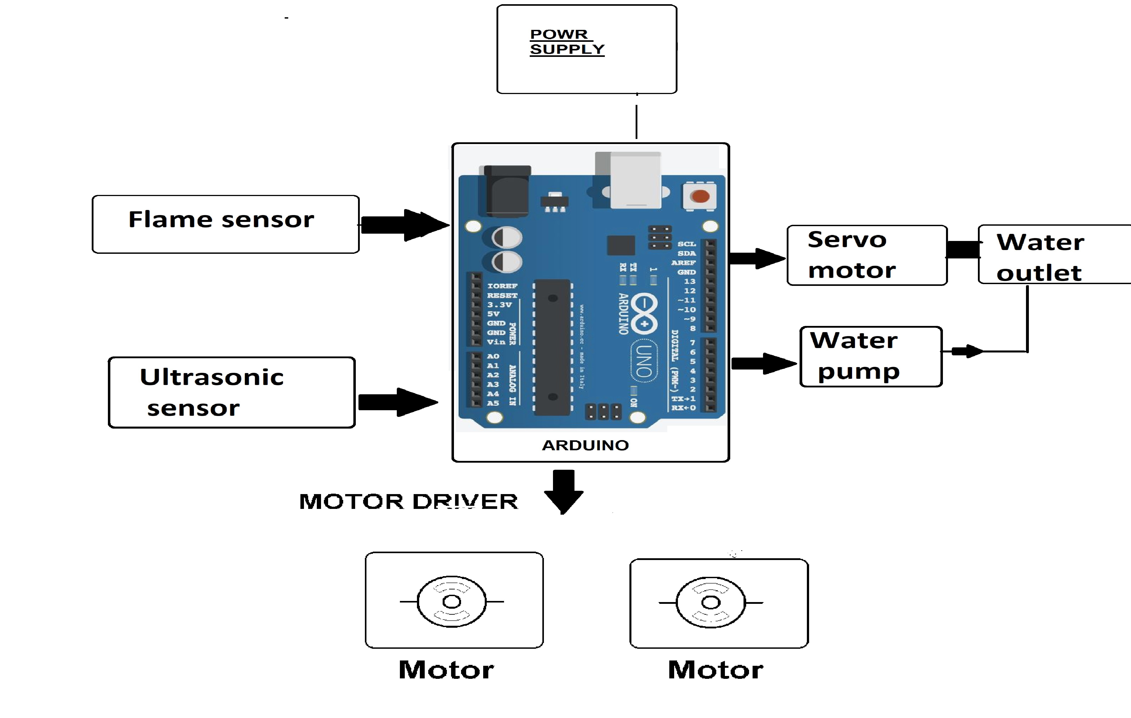

**Hardware Specifications**

* Arduino Uno
* Ultrasonic Sensor
* Fire Fighter Robot Body
* Fire Sensor
* Buzzer
* LCD Display
* Resistors
* Capacitors
* Transistors
* Cables and Connectors
* Diodes
* PCB and Breadboards
* LED
* Transformer/Adapter
* Push Buttons
* Switch
* IC
* IC Sockets
* Water tank

**Software Specifications**

1. Arduino Compiler
2. Programming Language: C

**RESULTS AND CONCLUSIONS**

The Fire Fighting Robot employs DTMF technology to control the directions of the robot. We design the fire detection system using flame sensor that is capable of sensing the flame of wavelength range 760 to 1100 nm, and the sensing range depends on the sensitivity and varies from 10cm to 1.5feet. The robot can operate in the environment which is out of human reach in very short time, the delay employed is very minimal. The robot accurately and efficiently finds the fire and within minimum time after the fire is detected it is extinguished.